INTRODUCTION:

1.Project Overview:

This project aims to develop a vehicle management system using Salesforce, focusing on streamlining fleet operations, improving asset tracking, and enhancing customer service within the automotive industry, ultimately leading to cost savings and increased efficiency.

2.Purpose:

Using Salesforcefor vehicle management aims to:

1.Improve efficiency.

2. Customer engagement.

3.Sales processes within the automotive industry by providing a centralized platform for managing everything from sales and service to inventory and connected vehicle data.

IDEATION PHASE

Branstroming& Idea Prioritization

|  |  |
| --- | --- |
| Date | 31 January 2025 |
| Team ID | LTVIP2025TMID19432 |
| Project Name | Vehicle Management Using Salesforce |
| Maximum Marks | 4 Marks |

Branstroming& Idea prioritization:

Brainstorming provides a free and open environment that encourages everyone within a team to participate in the creative thinking process that leads to problem solving.

Prioritizing volume over value, out-of-the-box ideas are welcome and built upon, and all participants are encouraged to collaborate, helping each other develop a rich amount of creative solutions.

Step-1: Team Gathering,Collaboration and Select the Problem Statement:

Problem Statement:

Vehicle Management System is an software application which fulfills the

requirement of a typical management of details of vehicles, staff, expenses and the

fleet and reports in a company along with Booking option. It provides the interface to

Users in a graphical way to manage the daily transactions. Also provides the

Management Reports like Vehicle Request details, Vehicle Request Status, Vehicle

Fuel Consumptions, Vehicle Distance Records, Vehicle Repair and Maintenance

Recordsand User Feedbacks.

The systems that are available now a days are manual ones in which users are

maintaining books to store the information like vehicles details, Booking

Details, Vehicle requests and approvals, Reports Management etc.

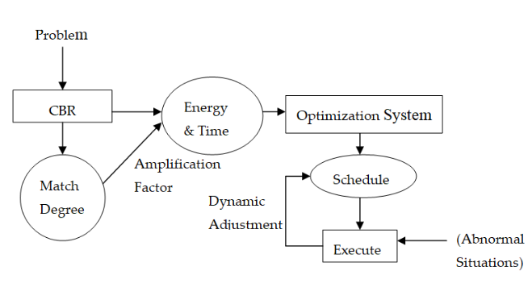

Step-2:Brainstorm, idea Listening and Grouping:

To brainstorm ideas for a vehicle management system consider features like real-time location tracking, optimized route planning, predictive maintenance alerts, and fuel consumption monitoring, all while focusing on local road conditions and traffic patterns.

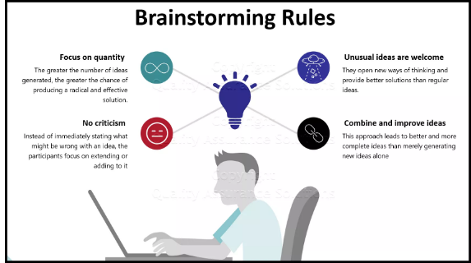

Step-3:Idea Prioritization

To prioritize ideas for a vehicle management system focus on solutions that address local needs, improve traffic flow, and enhance safety and efficiency, while considering factors like cost, feasibility, and scalability.

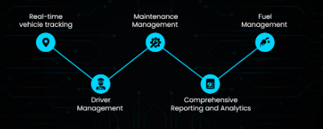

Define the Problem Statements

|  |  |
| --- | --- |
| Date | 31 January 2025 |
| Team ID | LTVIP2025TMID19432 |
| Project Name | Vehicle Management Using Salesforce |
| Maximum Marks | 2 Marks |

Customer Problem Statements

|  |  |  |  |  |  |
| --- | --- | --- | --- | --- | --- |
| Problem statement(PS) | I am  (customer) | I’m trying  to | But | Because | Which makes me feel |
| PS-1 | P. Nandini | Software  Engineer | Security  issues | Technical  debt | I get excited I find something  Great |
| PS-2 | B.Hemalatha | IAS | Corruption | Political  interference | A sense of  Fulfilment |

Empathize & Discover

|  |  |
| --- | --- |
| Date | 31 January 2025 |
| Team ID | LTVIP2025TMID19432 |
| Project Name | Vehicle Management Using Salesforce |
| Maximum Marks | 4 Marks |

Empathy Map Canvas:

1. An empathy map canvas, when applied to a vehicle management system, helps understand user needs and pain points by mapping what they think, feel, say, and do, ultimately informing design and development decisions to improve the user experience.

2. An empathy map is a tool used to gain a deeper understanding of a user's perspective, motivations, and needs.

3. It's a visual representation that helps designers and developers empathize with the user by exploring their thoughts,

feelings, actions, and environment.

EMPATHY MAP

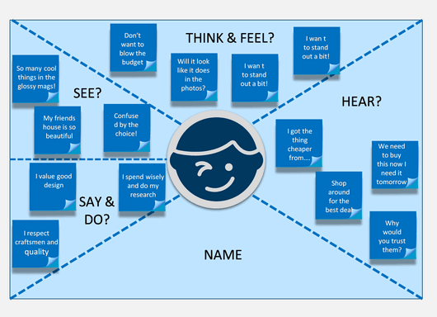

Conclusion:

To ideate a vehicle management system using Salesforce, focus on streamlining fleet operations, enhancing data management, and improving customer experiences. Consider features like real-time tracking, maintenance scheduling, driver management, and integration with other Salesforcemodules for a holistic approach.

THANKYOU TEAM SMARTBRIDGE

TEAMLEADER(Hemalatha)